

Contact
Chris Houser Tim Trainor
Cofounder DeVitis Design
InterSeeder Technologies (484) 580-8168
(814) 360-9412 (313) 995-2555
interseeder.chris@gmail.com trainorcomm@comcast.net

New InterSeeder™ Plants June Cover Crops
While Spraying Fertilizer and Herbicides In
Single Passes Between Knee-High Corn Rows

Proprietary Machine Saves Time, Cuts Costs
Reduces Erosion And Replenishes Soil

InterSeeder Technologies Receives License
To Market All-In-One Unit From Penn State

WOODWARD, Pa. (July, 2014) – InterSeeder Technologies, a new company affiliated with Penn State University, has launched commercial sales of InterSeeder™, a multipurpose machine that simultaneously plants three rows of cover crops while spraying post-emergent herbicide and nitrogen fertilizer in single passes between four or six rows of knee-high corn.
The proprietary all-in-one unit, which converts to a no-till grain drill, is the culmination of four years of field tests conducted during on-farm trials by Penn State in collaboration with the USDA, Cornell University and the University of Vermont. Trials took place at more than a dozen research and privately owned farms in Vermont, New York, Pennsylvania and Maryland.
“InterSeeder™ is the only machine on the market enabling farmers to plant winter cover crops during June among growing stands of corn while spraying fertilizer and weed-killing herbicides in one operation,” said Chris Houser, cofounder of InterSeeder Technologies. “Farmers in regions where post-harvest planting seasons often are too short now can produce cover crops that save on planting costs, improve yields and supply fall and spring forage.”

2

Cover crops are one of the most cost-effective and environmentally sustainable ways to control soil erosion and reduce nutrient pollution, Houser said.
Field trials verified that mixtures of annual and perennial ryegrass, clovers, hairy vetch, radishes, alfalfa and other grasses provide cover during spring and fall that prevent nutrient runoff. Cover crop winter root growth also captures and retains nutrients and replenishes soil.
InterSeeder™ semimounted no-till grain drill simplifies relay planting and sustainable farming and helps increase corn crop yields. An all season implement, it operates effectively with a 90-horsepower tractor for planting wheat, cereal rye and soybeans, and its 10-foot length allows easy hauling on roads.
Penn State Plant Science Department faculty members designed and engineered InterSeeder™ and formed InterSeeder Technologies last December after receiving a license from the university to sell the machine in commercial markets.
A fully equipped InterSeeder™ with four or six-row configurations costs $29,999, which includes seed planter, fertilizer and herbicide applicators, and no-till grain drill. The basic seed planter unit is priced at $22,000.
For more information about InterSeeder™, go to interseedertech.com, or call Corey Dillon at (814) 404-0684 at InterSeeder Technologies headquarters in Woodward, Pa.

Note To Editors: Photos on the following pages depict and describe how InterSeeder™ operates. Click here to watch a five- minute video about the machine.

3
Click on any low-res photo below to generate a 300 dpi version, or download from the newsroom photo gallery at interseedertech.com
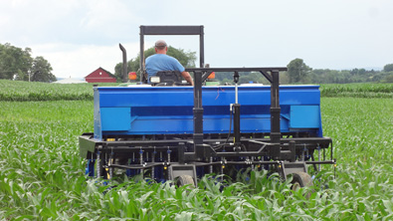
The new InterSeeder™ from InterSeeder Technologies of Woodward, Pa., simultaneously plants three rows of cover crops while spraying post-emergent herbicide and nitrogen fertilizer in single passes between four or six rows of knee-high corn. InterSeeder Technologies markets the machine under a license agreement with Penn State University.

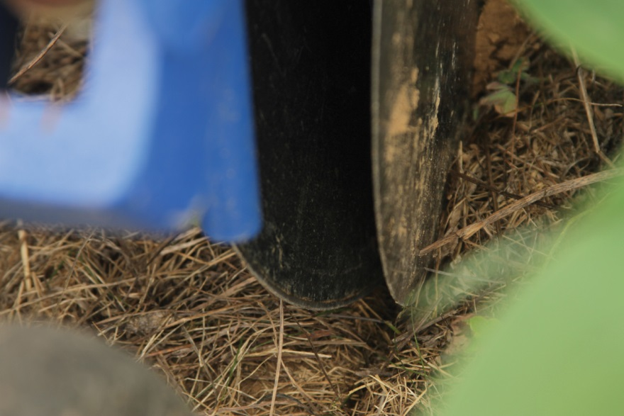
Double disk furrow openers ensure uniform seed trenches in diverse field conditions.

4
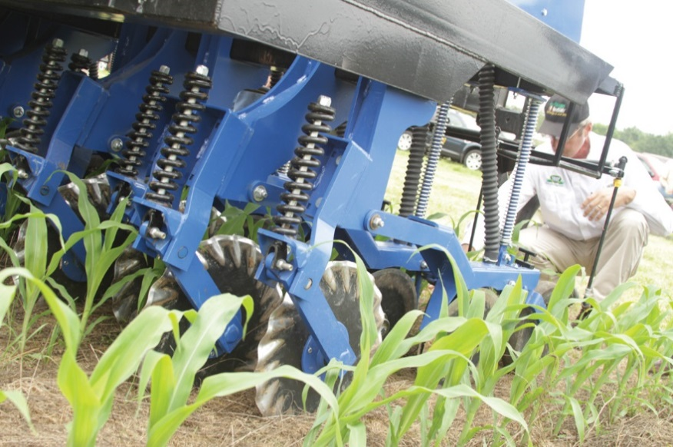
Wavy coulter cuts narrow strip zones between 30-inch corn rows as seeds are dispersed through tubes onto three rows of freshly tilled soil. Different types of coulters are used depending on soil hardness.

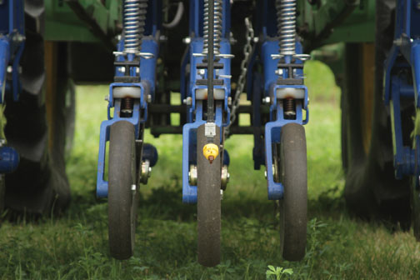
Cultipacking wheels establish troughs that embed seeds to one-half to three-quarter inch depths depending on cover crop species. InterSeeder™ all-in-one operations take place in June when corn is at V8 or less growth stage, about 18 inches high with six to eight leaves

5
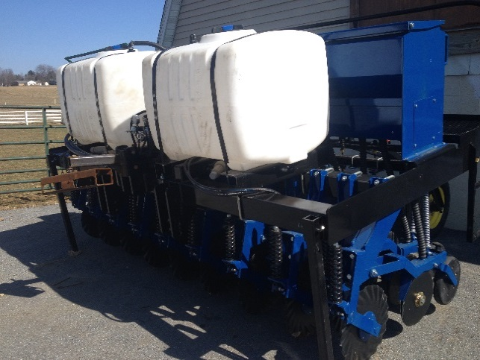
Herbicide and nitrogen tanks mounted on InterSeeder™ attach to hoses with four drop nozzles for applications shrouded by corn canopy. High pressure UAN nozzles apply nitrogen fertilizers four inches off the corn rows and four inches above the soil in a three-quarter-inch band to avoid damaging corn or cover crop.

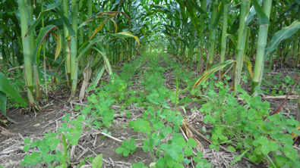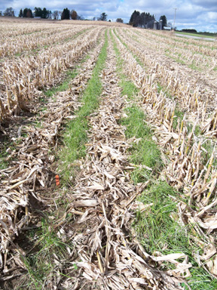
At left, cover crops lie dormant under canopy of shade provided by maturing corn. At right, cover crop in full growth following corn harvest and withering of stalks. Depending on local environments and farm requirements, cover crops planted by InterSeeder™ work most effectively with species or mixtures of annual ryegrass, clovers, hairy vetch, radishes, alfalfa and other grasses that provide cover during spring and fall that prevent nutrient runoff. Cover crop winter root growth also captures and retains nutrients and replenishes soil.

